**Lok Jagruti Kendra**

**University Course - Integrated MSc (IT)**

**BSc (IT) - Semester-I**

Subject Code :-050020204

Subject Name: - Skill Development Web Tools

RollNo :-- 08

Name of the Student:-- Pratik Chotaliya

Division : D

**Plagiarism Declaration**

To whom so ever it may concern

I/ We, the project team, confirm that this assignment is my own work, is not copied from any other person's work (published or unpublished), and has not previously submitted for assessment either at University or elsewhere. I/We confirm that I/we have read and understood the rules regulations on plagiarism in LJKU.

|  |  |  |
| --- | --- | --- |
| Enrollment no | Name | Sign |
| 21004500210194 | Pratik Chotaliya |  |

**Unit 2**

1. An Introduction to Connecting to Data in Tableau. • Connect employee.xlsx file and give name “unit2_EL_1”

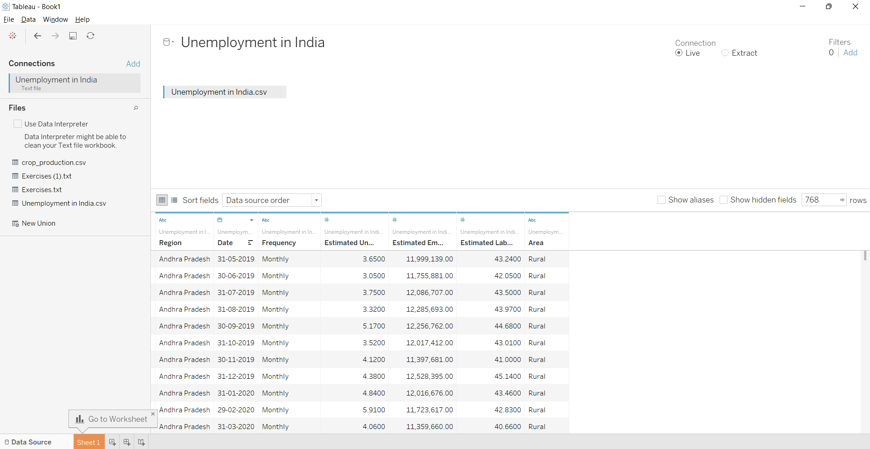

Introduction to Joins • Apply different types of joins on employee.xlsx file and give name “unit2_EL_2“



